**CO2 Triple Point Determination and Enthalpy of Sublimation Calculation.**

Nathan Gillispie. Date of experiment: September 28, 2022. Lab partner: Chloe

**Introduction:**

Carbon dioxide sublimates at atmospheric pressures and below. When solid carbon dioxide is placed in a closed container, the pressure rises until an equilibrium is achieved between the solid and gas phase. Assuming heat flows into the system reversibly, the pressure and temperature remain on the solid-gas phase transition boundary until the triple point is reached. Here, the temperature and pressure are constant as all heat flowing into the system goes to the phase transition of carbon dioxide.

The Clausius-Clapeyron equation relates temperature and pressure at a phase transition for a substance. The equation can be used to calculate the enthalpy of sublimation (ΔHsub) using gas constant (R) and experimentally determined pairs of temperature (T) and pressure (P):

|  |  |
| --- | --- |
| $$\ln\left(\frac{P_{2}}{P_{1}}\right)=-\frac{ΔH_{sub}}{R}\left(\frac{1}{T_{2}}-\frac{1}{T_{1}}\right)$$ | (1) |

The Clausius-Clapeyron equation can also be rearranged for an infinitesimal change in P and T:

|  |  |
| --- | --- |
| $$\frac{d ln\left(P\right)}{d\left(\frac{1}{T}\right)}=-\frac{ΔH_{sub}}{R}$$ | (2) |

The enthalpy of sublimation is assumed to be constant for the relevant temperature range. This yields an alternate expression for calculating ΔHsub.

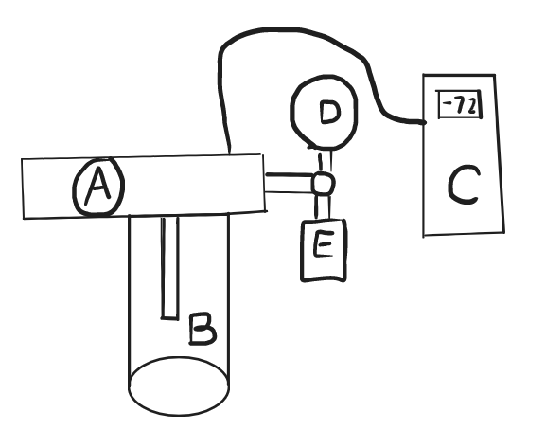**Methods:**

**Figure 1:** Diagram of the apparatus. It used a threaded cup (B), pressure gauge (D), thermometer (C), pressure valve (A) and relief valve (E).

The apparatus used for the experiment was made primarily of five parts as shown in figure 1. The cup was thick and plastic to allow heat to flow into the system. The threads allow a tight seal to be created between the rest of the apparatus. The thermometer was placed to allow the thermocouple to be touching the liquid carbon dioxide. The wire from the thermocouple was threaded through the apparatus, exiting with an airtight seal to go to a digital readout. The pressure gauge gave an analog reading from the pressure within the cup. The valve was designed to be manually operated and to allow partial activation to so pressure can be released slowly.

Crushed solid carbon dioxide was placed in the cup of the apparatus and screwed on tight. The valve was closed the first time and the system was allowed to reach about 10 psi. The system was checked for leaks and the valve was opened to release the pressure again. The valve was closed the second time and the temperature and pressure readings immediately began. Values were recorded at 5 second intervals simultaneously. Once the triple point was reached, a few more data points were collected. The pressure was released by opening the valve partially. Once the pressure fell below that of the triple point, the valve was fully opened and the CO2 was removed from the cup.

**Data:**

**Plot 1:** Pressure versus Temperature diagram of carbon dioxide. The four points in the top right are the triple point.

**Plot 2:** Logarithmic pressure over invers temperature with best fit data.

**Table 1:** Randomly selected points for calculation of ΔHsub.

|  |  |  |  |  |  |
| --- | --- | --- | --- | --- | --- |
|  | T1 (K) | P1 (atm) | T2 (K) | P2 (atm) | ΔHsub(J/mol) |
| 1 | 215.25±0.5 | 4.349±0.034 | 202.85±0.5 | 1.797±0.034 | 25900±300 |
| 2 | 216.25±0.5 | 4.757±0.034 | 213.45±0.5 | 3.873±0.034 | 28000±3000 |
| 3 | 216.75±0.5 | 4.893±0.034 | 199.65±0.5 | 1.389±0.034 | 26500±100 |
| 4 | 211.05±0.5 | 3.260±0.034 | 216.75±0.5 | 4.893±0.034 | 27000±2000 |
| 5 | 216.75±0.5 | 4.893±0.034 | 202.25±0.5 | 1.695±0.034 | 26600±300 |
| 6 | 213.85±0.5 | 4.009±0.034 | 198.65±0.5 | 1.287±0.034 | 26400±80 |
| 7 | 200.55±0.5 | 1.491±0.034 | 205.55±0.5 | 2.171±0.034 | 25800±300 |
| 8 | 206.65±0.5 | 2.376±0.034 | 207.75±0.5 | 2.580±0.034 | 27000±9000 |
| 9 | 211.05±0.5 | 3.260±0.034 | 209.15±0.5 | 2.852±0.034 | 26000±2000 |
| 10 | 201.45±0.5 | 1.593±0.034 | 215.95±0.5 | 4.621±0.034 | 26600±400 |
| $$\overline{x}±\overline{δ}$$ |  |  |  |  | 26600±1700 |

**Results and Discussion:**

The absolute pressure was calculated as the sum of the gauge measurement and the ambient atmospheric pressure (14.91±0.01)psi as obtained from historic weather data.1 When added to the pressure as measured from the analogue gauge with uncertainty ±0.5psi, the absolute pressure uncertainties all became ±0.034atm.

The absolute temperature data originated from the digital thermometer which had uncertainty of ±0.05K. The calculation of ΔHsub went according to Eq. 1. The uncertainties were propagated using worst case scenario: For example:

$$\frac{\ln\left(\frac{P_{2}}{P_{1}}\right)R}{\left(\frac{1}{T_{1}}-\frac{1}{T_{2}}\right)}=\frac{\ln\left(\frac{(1.80±.03)atm}{(4.35±.03)atm}\right)8.314\frac{J}{mol K}}{\left(\frac{1}{\left(215.25±0.5\right)K}-\frac{1}{(202.85±0.5)K}\right)}=(25900±1700)J$$

When calculated for 10 randomly selected pairs, some pairs land very close to each other, giving a much higher uncertainty in ΔHsub than for points that are further apart. This is proven by pair 8 (highest uncertainty pair) which consists of two points separated by just one other point. If the points were selected such that they were all at least given number of points (say 10) away from each other, the uncertainty in the point-point calculation would be lower.

When observing plot 2, the uncertainty of the slope can be found through the worst-case scenario slope as calculated by taking the top right most possible value for the first data point and drawing a line to the bottom left most value of the right most point. The stated values are (0.00504 1/K, 0.17 ln atm) and (0.00461 1/K, 1.628 ln atm). The worst-case scenario slope-derived ΔHsub is

$$-8.314\frac{J}{mol K}\frac{\left(1.628-0.17\right)\ln{atm}}{\left(0.00461-0.00504\right)\frac{1}{K}}=28190\frac{J}{mol}$$

The actual slope-derived ΔHsub is calculated using Eq. 2:

$$-8.314\frac{J}{mol K}*-3193.4\frac{\ln{atm}}{\frac{1}{K}}=26550\frac{J}{mol}$$

This implies ΔH calculated from the fit data is 26600±1600 J/mol and 26600±1700 J/mol for the randomly selected points. This represents an uncertainty of 6.2% compared to an uncertainty of 6.4% for the randomly selected points. The values are actually identical which is likely due to the highly linear nature of the data. Unfortunately, the uncertainties of both values are >5%. If we take a look at the uncertainty in the logarithmic pressure, the worst-case scenario calculations result in much larger uncertainties for the lowest pressure values than for the highest pressure values (±.14atm and ±0.007atm for the lowest and highest points respectively). This has such a large effect near ambient atmospheric pressure that just by knocking off the first data point, the logarithmic pressure uncertainty of the rest of the set remains below 0.026atm.

When compared to the literature value we find ΔHsub to be 26.1 kJ/mol for the range 198K to 216K.2 For our 10 random points, the values agree within two standard deviations because 26.1 kJ/mol falls within 26.6±1.7 kJ/mol. For our slope data, the two values agree because 26.1 kJ/mol falls within 26.6±1.6 kJ/mol

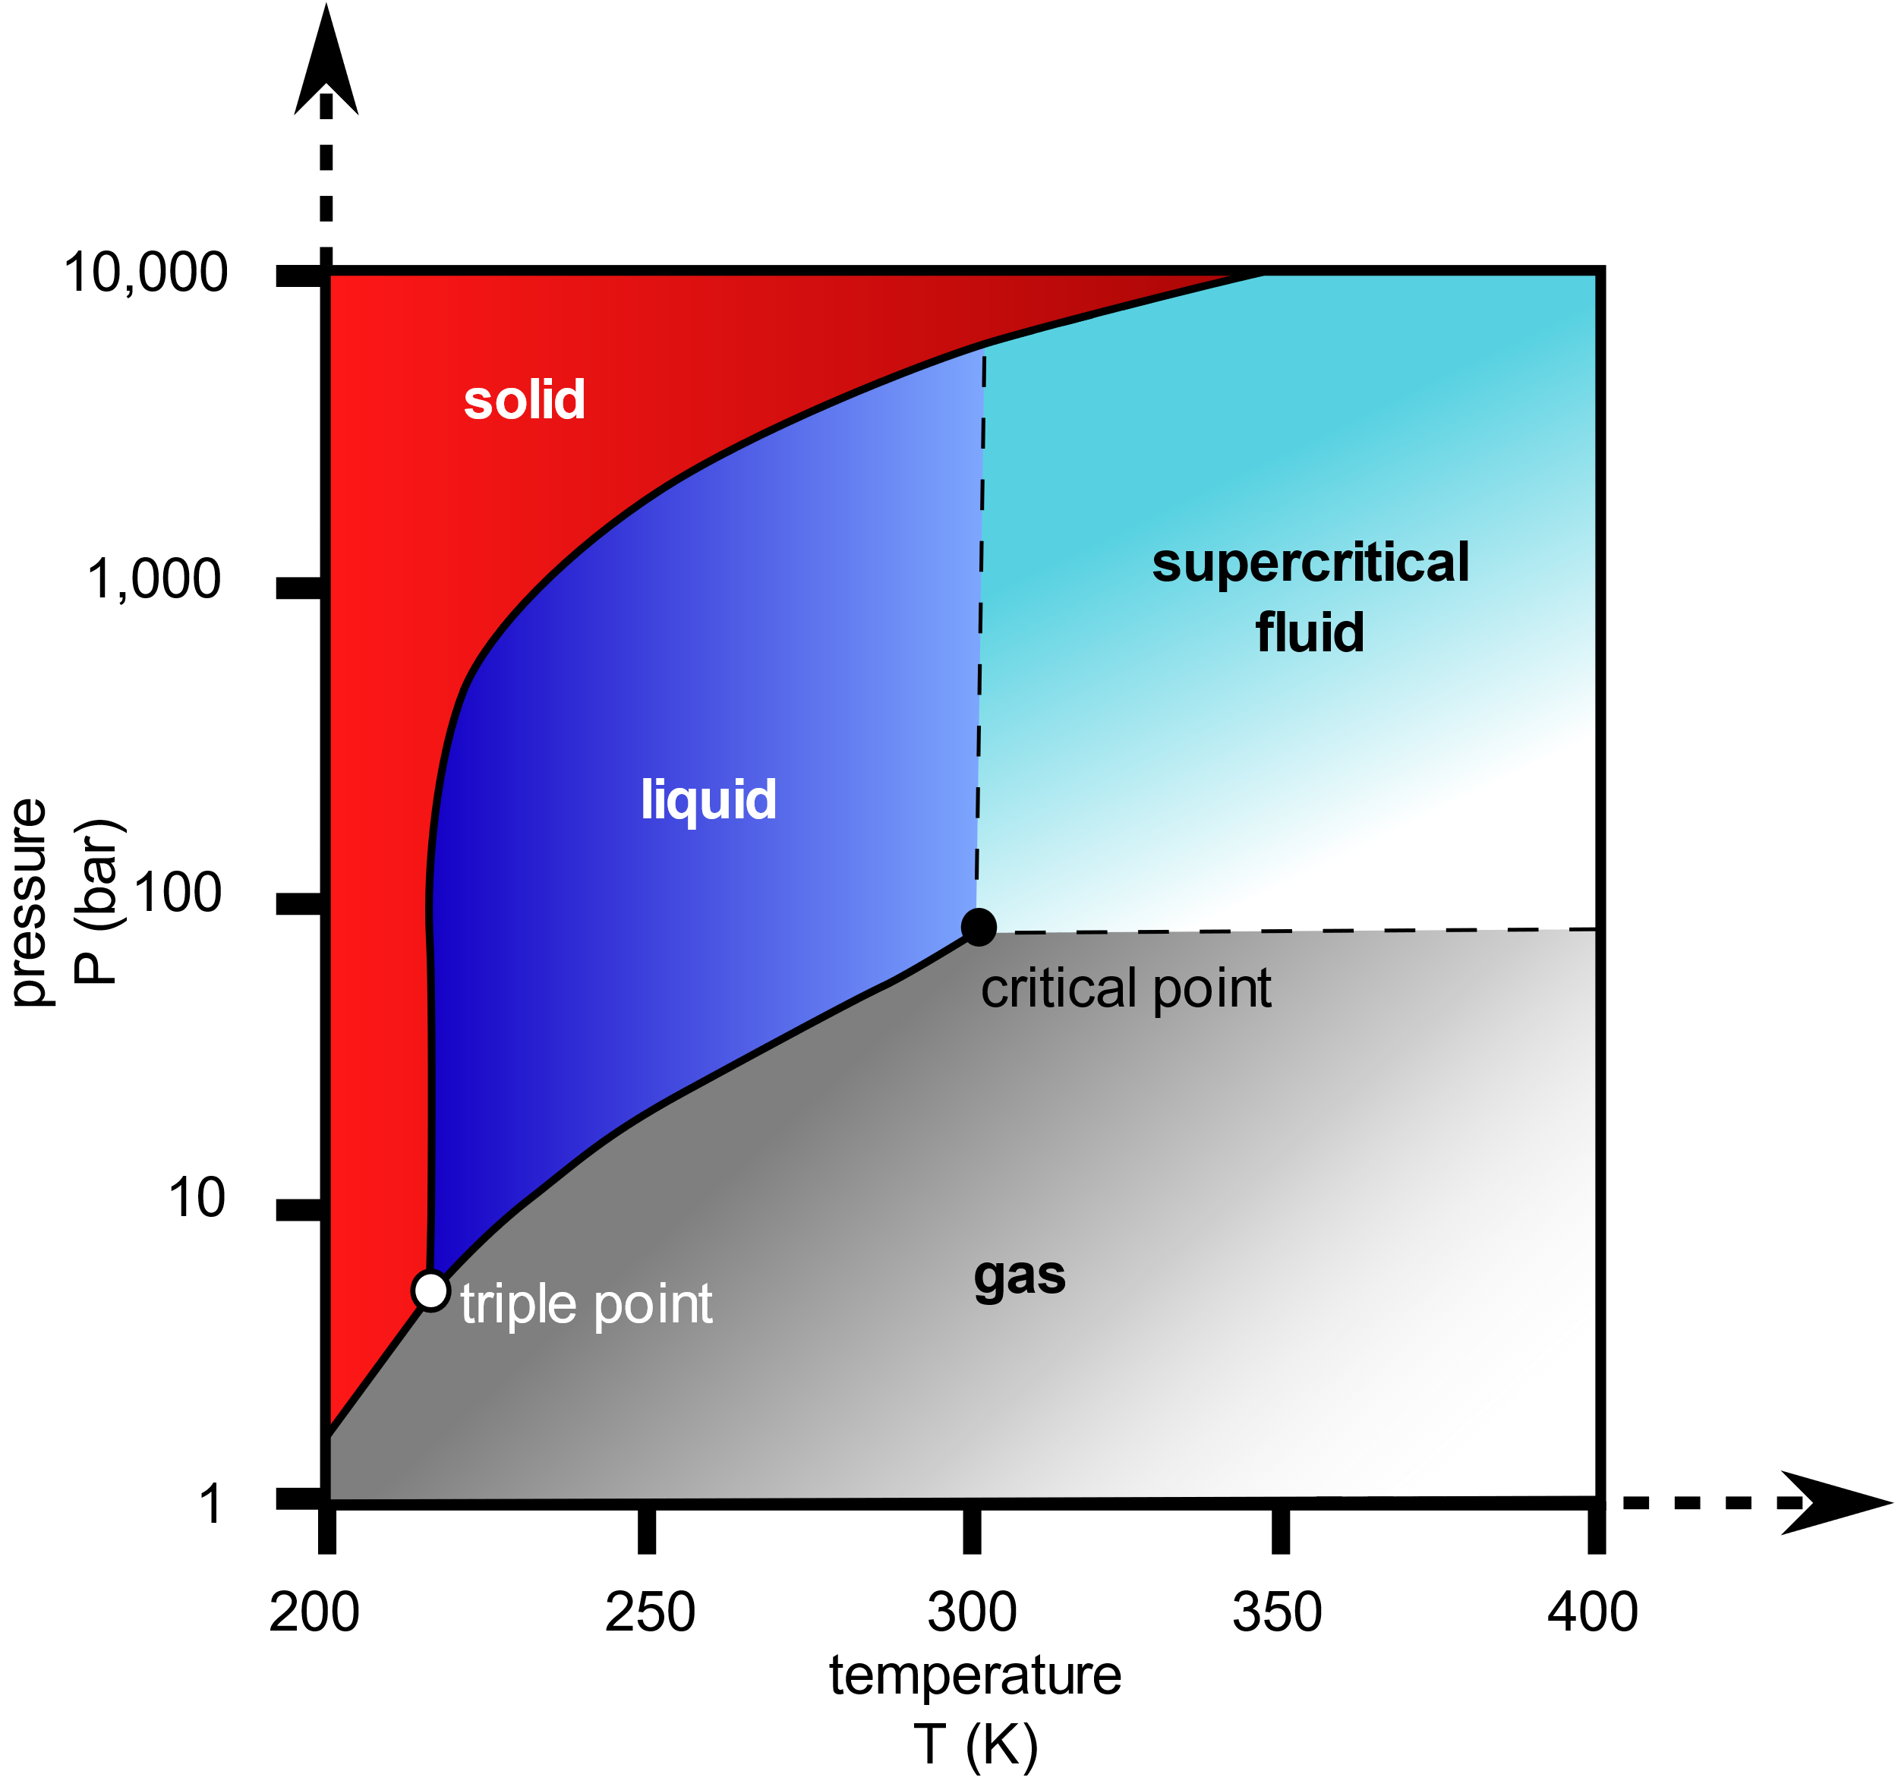

**Figure 2:** P/T phase diagram of CO2 with triple point located in the bottom left.

The triple point can be determined by looking only at plot 1. Since the rate of heat flow is effectively constant, a set of many points sharing the same pressure and temperature is the triple point. This is because the flow of heat into the system raises both the pressure and temperature, however, since solid and gas are in equilibrium, the points follow what is the solid-gas phase boundary line on a phase diagram as shown in figure 2. Eventually, the pressure increases enough so that liquid carbon dioxide forms. This decreases the degrees of freedom according to the phase rule and forces the temperature and pressure to remain constant until one of the phases is removed.

If we take the average of the four points in the top right corner of plot 1, we get T=(216.8±0.1)K and P=(5.105±0.03)atm. The triple point of CO2 is (216.588±0.005)K and (5.11216±0.0006)atm.3 The temperature values agree within two standard deviations and the pressure values do as well.

**Conclusion:**

The triple point of a compound is a highly reproducible state with constant temperature and pressure. The measured triple point value was T=(216.8±0.1)K and P=(5.105±0.03)atm, which both agrees within two standard deviations of the literature.

The Clausius-Clapeyron equation is also a commonly used and accurate method of determining enthalpy of sublimation. The calculated value using the slope method was 26.6±1.6 kJ/mol and 26.6±1.7 kJ/mol for the random point pair method. Both values agree within one standard deviation to the literature.

**Safety:**

Although carbon dioxide is abundant in our body and atmosphere, it still poses an asphyxiation risk in large concentrations in gas form.4 Only conduct this experiment in a ventilated area. In solid form, contact may cause cold burns or frost bite.4 The first recorded temperature of this experiment was -75°C.

**References:**

1. *Past Weather in Bowling Green, Kentucky;* Time and Date AS: Stavanger, Norway, 2022. <https://www.timeanddate.com/weather/usa/bowling-green/historic?month=9&year=2022> (accessed October 10, 2022)
2. Chickos, J. S.; Acree, W. E. Enthalpies of Sublimation of Organic and Organometallic Compounds. 1910–2001. J. Phys. Chem. Ref. Data 2002, 31 (2), 537–698. <https://doi.org/10.1063/1.1475333> (accessed October 10, 2022)
3. C. H. Meyers and M. S. Van Dusen, Bur. Stand. J. Res. **10**, 381 (1933).
4. *Carbon dioxide (solid);* MSDS No. 001040; Airgas: Radnor, PA, August, 31, 2021. <https://www.airgas.com/msds/001040.pdf> (accessed October 10, 2022)